**Breakout C**

For this breakout, your task is to take the content for the homepage of a bird watching website and add structural elements to it so it can have a page layout applied to it. It needs to have:

* A header spanning the full width of the site containing the main title for the page, the site logo, and the navigation menu. The title and logo appear side by side once styling is applied, and the navigation appears below those two items.
* A main content area containing two columns - a main block to contain the welcome text, and a sidebar to contain image thumbnails.
* A footer containing copyright information and credits.

You need to add a suitable wrapper for:

* The header
* The navigation menu
* The main content
* The welcome text
* The image sidebar
* The footer

You should also:

Apply the provided CSS to the page by adding another [<link>](https://developer.mozilla.org/en-US/docs/Web/HTML/Element/link) element just below the existing one provided at the start.

**Hints and tips**

* You don't need to know any CSS to do this assessment; you just need to put the provided CSS inside an HTML element.
* The provided CSS is designed so that when the correct structural elements are added to the mark-up, they will appear green in the rendered page.
* If you are getting stuck and can't envisage what elements to put where, it often helps to draw out a simple block diagram of the page layout, and write on the elements you think should wrap each block.

Example

The following screenshot shows an example of what the homepage might look like after being marked up.

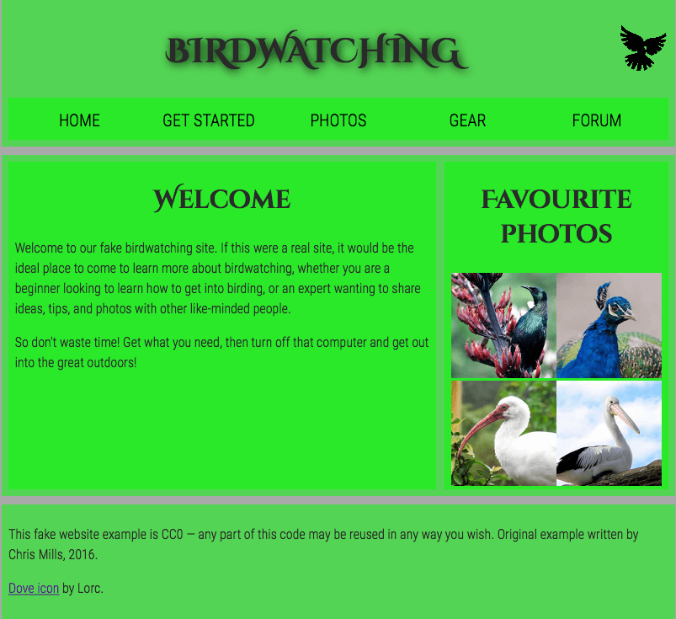

**Note**

HTML5 introduced new [structurally based elements](http://dev.opera.com/articles/new-structural-elements-in-html5/), including the <header>, <nav>, <article>, <section>, <aside>, and <footer> elements.

All of these new elements are intended to give meaning to the organisation of our pages and improve our structural semantics. They are all block-level elements and do not have any implied position or style. Additionally, all of these elements may be used multiple times per page, so long as each use reflects the proper semantic meaning.

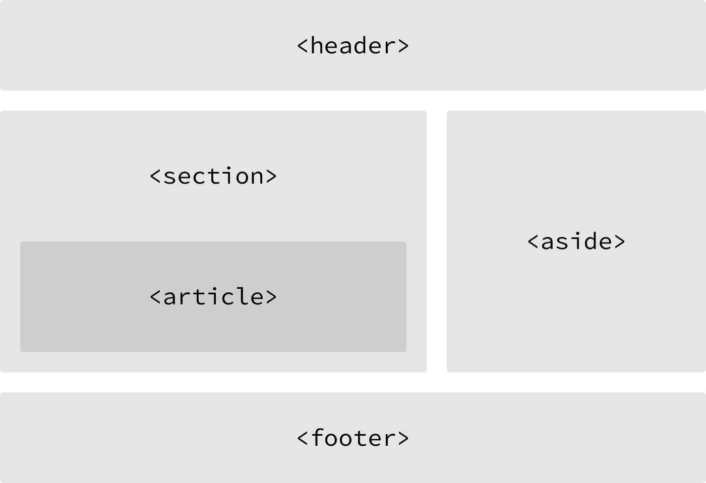

Block vs. Inline Elements

Most elements are either block- or inline-level elements. What’s the difference?

Block-level elements begin on a new line, stacking one on top of the other, and occupy any available width.

Block-level elements may be nested inside one another and may wrap inline-level elements. We’ll most commonly see block-level elements used for larger pieces of content, such as paragraphs.

Inline-level elements do not begin on a new line. They fall into the normal flow of a document, lining up one after the other, and only maintain the width of their content. Inline-level elements may be nested inside one another; however, they cannot wrap block-level elements. We’ll usually see inline-level elements with smaller pieces of content, such as a few words.